Domestic Violence Awareness Month
Social Media Toolkit | October 2020
Hashtags: #DVAM #DVAM603

How to Use this Toolkit
October is Domestic Violence Awareness Month (DVAM), a time that is set aside to help raise awareness about the devastating impact that domestic violence has on survivors, their families, and the community at large. Recognizing DVAM this year is particularly critical knowing that the COVID-19 pandemic has exacerbated the experiences of survivors of domestic and sexual violence in in the Granite State.

One way to participate is to help engage with your community and provide education on what domestic is, who it impacts, and what we can do to prevent abuse before it occurs. We have created a series of template social media posts and accompanying graphics that you can use throughout the month. This toolkit includes posts for both Twitter and Facebook, but feel free to also use the graphics and post text for other social media platforms like Instagram. Thank you for your support in helping raise awareness about domestic violence here in New Hampshire!

Social Media Posts
Sample Tweets (Meets character limits)
Domestic violence is a major issue in New Hampshire, affecting over 10,000 individuals and families annually. This Domestic Violence Awareness Month let’s work together to end abuse in our communities. Confidential advocates are here to help: 1-866-644-3574. #DVAM603 #DVAM
Domestic violence is the most dangerous crime in New Hampshire, contributing to 45% of murders between 2018-2019. This Domestic Violence Awareness Month we must pledge to put an end abuse in our communities. Confidential advocates are here to help: 1-866-644-3574. #DVAM603 #DVAM
1 out of 4 LGBTQ people are victims of domestic violence. This Domestic Violence Awareness Month let’s work together to end all forms of violence and abuse. Confidential advocates are available 24/7 at our statewide hotline: 1-866-644-3574 #DVAM603 #DVAM
LGBTQ individuals can experience specific forms of abuse based on their identity, including threatening to out a partner’s sexual orientation or gender identity to family, friends or employers. Let’s end all forms of abuse. Help is available 24/7: 1-866-644-3574 #DVAM603 #DVAM
Domestic violence can happen to anyone, regardless of race, sexual orientation, gender identity, ability, or economic status. This Domestic Violence Awareness Month it’s time we end abuse in New Hampshire. Confidential advocates are here to help: 1-866-644-3574 #DVAM603 #DVAM
Domestic violence can take many forms, and is rarely a one-time occurrence, escalating in frequency and severity over time. This Domestic Violence Awareness Month we must work collectively to support those who need help in NH. Help is available: 1-866-644-3574 #DVAM603 #DVAM
Financial abuse is a form of domestic violence commonly used to trap someone in a relationship. It prevents victims from using financial resources, This Domestic Violence Awareness Month let’s advocate for economic justice. Help is available: 1-866-644-3574 #DVAM603 #DVAM
98% of victims of domestic violence experience financial abuse, preventing them from acquiring or using financial resources. This Domestic Violence Awareness Month let’s support survivors in achieving financial stability. Help is available: 1-866-644-3574 #DVAM603 #DVAM
People with disabilities report limited access to safety and support services in their communities. This Domestic Violence Awareness Month let’s protect everyone from abuse. Confidential advocates are here to help: 1-866-644-3574 #DVAM603 #DVAM
People with disabilities experience an extreme loss of power and control when their abuser is also their caretaker. This Domestic Violence Awareness Month let’s protect everyone from abuse. Confidential advocates are available 24/7: 1-866-644-3574 #DVAM603 #DVAM

Domestic violence may make children less likely to succeed in school. This Domestic Violence Awareness Month let’s work to ensure our children can grow up in violence-free homes. Confidential advocates are here to help: 1-866-644-3574 #DVAM603 #DVAM
Domestic violence makes children more likely to face a host of health problems that can last throughout their lives. This Domestic Violence Awareness Month let’s work to ensure our children can grow up in violence-free homes. Help is available: 1-866-644-3574 #DVAM603 #DVAM
Victims of domestic violence may experience many barriers to leaving. This Domestic Violence Awareness Month help remove barriers that leave survivors trapped in abusive relationships. Confidential advocates are ready to help: 1-866-644-3574 #DVAM603 #DVAM
Victims of domestic violence may experience many barriers to leaving, including fear of more violence or death. This Domestic Violence Awareness Month help remove barriers that leave survivors trapped in abusive relationships. Call now: 1-866-644-3574 #DVAM603 #DVAM
Research shows that the most dangerous time for a victim in an abusive relationship is when they decide to leave. This Domestic Violence Awareness Month let’s work to eradicate violence in NH and help survivors access the support they need. Call now: 1-866-644-3574 #DVAM603 #DVAM

Sample Facebook Posts:
Domestic Violence continues to affect millions of individuals annually throughout the United States. This Domestic Violence Awareness Month let’s work together to help end domestic violence in New Hampshire. Collectively, we have the power to prevent abuse. If you or someone you know is experiencing abuse, you can reach out to a confidential advocate at any time through the statewide hotline: 1-866-644-3574. #DVAM603 #DVAM
Domestic violence can happen to anyone, regardless of race, sexual orientation, gender identity, ability, or economic status. It can also take on many forms, such as physical violence, sexual violence, stalking, verbal, emotional, or economic abuse. Since March, cases of domestic violence have exacerbated due to the pandemic, leaving survivors vulnerable and in a heightened need for help. As we move into Domestic Violence Awareness Month this October, let’s work together to end domestic violence in the Granite State. Confidential advocates are here to help: 1-866-644-3574. #DVAM603 #DVAM
Research shows that the most dangerous time for a victim in an abusive relationship is when they decide to leave, and victims may experience many barriers to leaving. These barriers can include fear of more violence or death, cultural or religious values, fear of losing custody of their children, the hope that the abuser can change, and lack of financial independence. This Domestic Violence Awareness Month let’s work towards removing barriers that leave survivors trapped in abusive relationships. Confidential advocates are available 24/7: 1-866-644-3574 #DVAM603 #DVAM
98% of victims of domestic violence experience financial abuse, preventing them from acquiring, using or maintaining financial resources, and is a form of domestic violence commonly used to trap someone in a relationship. This Domestic Violence Awareness Month let’s support survivors in achieving financial stability and advocate for economic justice. Confidential advocates are here to help: 1-866-644-3574 #DVAM603 #DVAM
1 out of 4 LGBTQ people are victims of domestic violence, and LGBTQ individuals can experience highly specific forms of abuse based on their identity and community dynamics. One form of violence can be threatening to out a partner’s sexual orientation or gender identity to family, friends, employers, or in other situations where this may pose a threat. This Domestic Violence Awareness Month let’s work together to end all forms of violence and abuse. Confidential advocates are available 24/7 at our statewide hotline: 1-866-644-3574 #DVAM603 #DVAM
Domestic violence can happen to anyone, regardless of race, sexual orientation, gender identity, ability, or economic status. Domestic violence can also take on many forms, such as physical violence, sexual violence, stalking, and verbal, emotional, psychological, or economic abuse. Domestic violence can also include threats, shouting, strangulation, harming children or pets, and other violent or intimidating behaviors. Abusers will often try to isolate a victim from family and friends, and domestic violence is rarely a one-time occurrence, escalating in frequency and severity over time. This Domestic Violence Awareness Month it’s important that we work collectively to bring an end to abuse in New Hampshire and support those who need help. Confidential advocates are available 24/7: 1-866-644-3574 #DVAM603 #DVAM

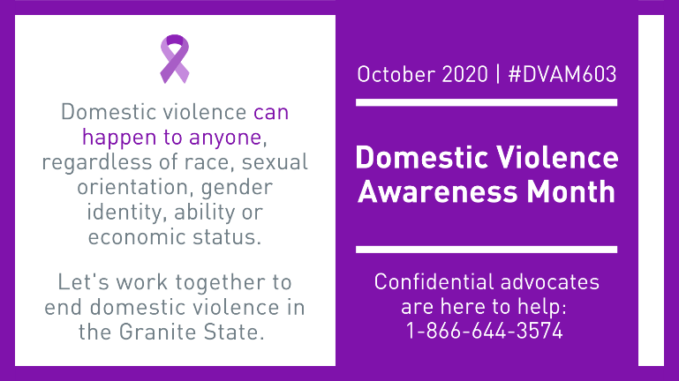
Social Media Graphics
By “right clicking” on each graphic, you can save it to your computer to use on social media
