Sexual Assault Awareness Month
Social Media Toolkit | April 2021
Hashtags: #SAAM #SAAM603

How to Use this Toolkit
April is Sexual Assault Awareness Month (SAAM), a time that is set aside to help raise awareness and draw attention to the prevalence of sexual violence in our state and across the nation. In New Hampshire, sexual assault is a serious crime, where 1 in 4 women and 1 in 20 men have reported experiencing some form of sexual violence in their lifetimes.

One way to participate is to help engage with your community and provide education on what sexual violence is, how it affects victims and our communities, and what we can do to prevent abuse before it occurs. We have created a series of template social media posts and accompanying graphics that you can use throughout this awareness month. This toolkit includes posts for Twitter Facebook, and Instagram, but feel free to also use the graphics and post text for other social media platforms. Thank you for your support!

Free & Confidential Services in New Hampshire

New Hampshire's 12 domestic and sexual violence crisis centers provide free and confidential support services to people impacted by domestic violence, sexual assault, stalking, human trafficking, and/or child abuse. Anyone can call the state’s 24/7 helpline at 1-866-644-3574. You don’t need to be in crisis to call, and you can call on behalf of a loved one or friend. Advocates are trained to support survivors in identifying next steps, safety planning, and connecting them with resources and services in their communities.

Sample Tweets

Help raise awareness to address sexual violence in your own community this April. In NH, sexual assault is a serious crime, where 1 in 4 women and 1 in 20 men have reported experiencing some form of sexual violence. Help is here: 1-866-644-3574. #SAAM603

In New Hampshire, sexual assault is a serious crime. 1 in 4 women and 1 in 20 men have reported experiencing some form of sexual violence in their lifetimes. Confidential advocates are here to help 24/7 at 1-866-644-3574. #SAAM603 #SAAM

In New Hampshire, 1 in 20 men report being sexual assaulted, with a majority having experienced that abuse before their 18th birthday. Sexual assault is devastating, regardless of gender, and help is available: 1-866-644-3574. #SAAM603 #SAAM
Sexual assault can happen to anyone, regardless of race, sexual orientation, gender identity, age, social background, or economic status. The healing process can look different for every survivor and that’s okay. Advocates are here to help: 1-866-644-3574. #SAAM603 #SAAM

This Sexual Assault Awareness Month we want survivors to know that you deserve to be believed, heard, and supported. It is not your fault, and you are not alone. Confidential advocates are available 24/7: 1-866-644-3574. #SAAM #SAAM603
LGBTQ+ people experience higher rates of stigma, marginalization, and hate-motivated violence, all factors that place them at higher risk for sexual assault. This month let's work together to end all forms of sexual violence and abuse. #SAAM #SAAM603

If you suspect a child is being abused or witnessing domestic or sexual violence, take a stand. Be a voice for a child. To report suspected abuse call NH DCYF at 603-271-6562, and seek help through NH's 24/7 statewide helpline: 1-866-644-3574 #SAAM #SAAM603

When someone has experienced sexual violence, whether the assault was recent or many years ago, the support and understanding of family and friends makes all the difference. Help is available and you don’t have to be in crisis to call: 1-866-644-3574. #SAAM

Sample Facebook and Instagram Posts:
April is Sexual Assault Awareness Month (SAAM), a time that is set aside to help educate and draw attention to the prevalence of sexual violence in NH and across the nation. In the Granite State, sexual assault is a serious crime, where 1 in 4 women and 1 in 20 men report experiencing a form of sexual violence. It’s critical that we work together to prevent abuse before it occurs.

If you or someone you know is experiencing abuse, you can contact NH's 24/7 helpline: 1-866-644-3574. Confidential advocates are here to help. You do not have to be in crisis to call.
------
This Sexual Assault Awareness Month we want survivors to know that you deserve to be believed, heard, and supported.
You are strong.
You are brave.
You are not alone.

If you or someone you know is experiencing sexual violence, you can contact NH's 24/7 helpline: 1-866-644-3574. Confidential advocates are here to help. You do not have to be in crisis to call.
------

Sexual assault can happen to anyone, regardless of race, sexual orientation, gender identity, age, social background, or economic status. Healing after sexual assault is a process that looks different for each survivor, and it may take months, years, or even decades.
New Hampshire’s 12 domestic and sexual violence crisis centers provide free and confidential support services to anyone impacted by domestic violence, sexual assault, stalking, human trafficking, or child abuse.
Services include:
- 24/7 support available on the confidential helpline
- Accompaniments to hospitals, police departments, courts, and child advocacy centers
- Emergency shelter
- Support groups
- Prevention education programming and in-service training
If you or someone you know is experiencing sexual violence you can contact NH's 24/7 Hotline: 1-866-644-3574. Confidential advocates are here to help. You do not have to be in crisis to call.
------

When sexual assault occurs, it is devastating to the victim regardless of gender. In New Hampshire, 1 in 20 men reported being sexual assaulted, with a majority having experienced abuse before their 18th birthday.

Men are entitled to equal services and support following a sexual assault. Whether or not a victim chooses to report to law enforcement or move forward with the criminal process, his local crisis center can provide referrals for counselors and/or support groups.

If you or someone you know is experiencing sexual violence, confidential advocates are available 24/7 through NH's helpline: 1-866-644-3574. You do not have to be in crisis to call.
------
LGBTQ+ people experience higher rates of stigma, marginalization, and hate-motivated violence, all factors that place them at higher risk for sexual violence. In intimate partner relationships, perpetrators often attempt highly specific forms of abuse based on identity and community dynamics, including tactics such as:
1) "Outing" or threatening to out a partner's sexual orientation or gender identity to family, friends, employers, or in other situations where this may pose a threat.
2) Telling the survivor that abusive behavior is a normal part of LGBT relationships.
3) Portraying the violence as mutual and even consensual, especially if the partner attempts to defend themselves from the abuse.
4) Interfering with hormones their partner is taking to transition or forcing their partner to transition.

If you or someone you know is experiencing sexual violence, you can speak with a confidential advocate 24/7 through NH's 24/7 helpline: 1-866-644-3574. You do not have to be in crisis to call.
------

Help raise awareness and address sexual violence in your community this April. In New Hampshire, sexual assault is a serious crime, where 1 in 4 women and 1 in 20 men have reported experiencing some form of sexual violence.

Sexual assault is forced, manipulated, or coerced sexual activity. Abusers use sex to inflict humiliation, exert power and control, or to use the victim to attain sexual gratification without regard for the victim’s consent.

If you or someone you know is experiencing sexual violence, confidential advocates are available by calling NH's 24/7 helpline: 1-866-644-3574. You do not have to be in crisis to call.
------

It is important for parents and caregivers to learn how to identify and respond to signs of abuse so that children feel safe and get connected with the resources they need to heal after experiencing sexual violence. These are complex issues, and you may feel ill equipped to talk to your child about them but starting is the most important step.

If you suspect a child is being abused or witnessing domestic or sexual violence, take a stand. Be a voice for a child. To report suspected child abuse call NH DCYF at 603-271-6562 and seek help through NH's 24/7 statewide helpline to learn more: 1-866-644-3574.
------
When someone has experienced sexual violence, whether the assault was recent or many years ago, the support and understanding of family and friends is critical. Many survivors say that the response they received when they first told someone made all the difference in their safety and healing process. There are many ways you can support a survivor, including:

- Stating that you believe them, and that it’s not their fault.
- Telling them they are not alone, that you care about them, and that you are there to listen without judgement.
- That you support them in whatever they decide to do.
- Help connect them with a confidential advocate or local crisis center for free services and support to identify next steps.

If you or someone you know is experiencing sexual violence, you can contact NH's 24/7 helpline: 1-866-644-3574. You do not have to be in crisis to call.

Sample Social Media Graphics
By “right clicking” on any of the following graphics, you can save them to your computer to use on social media.

Twitter Graphics

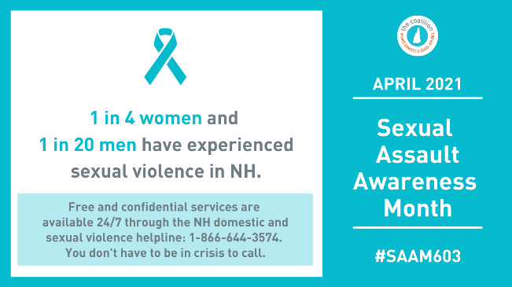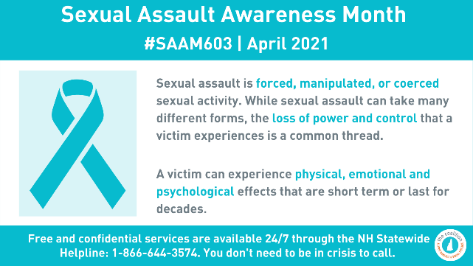
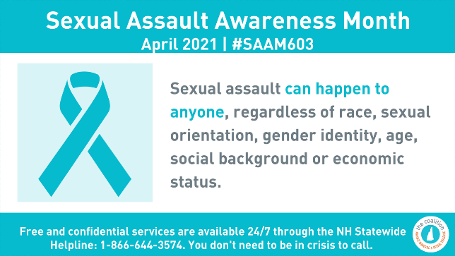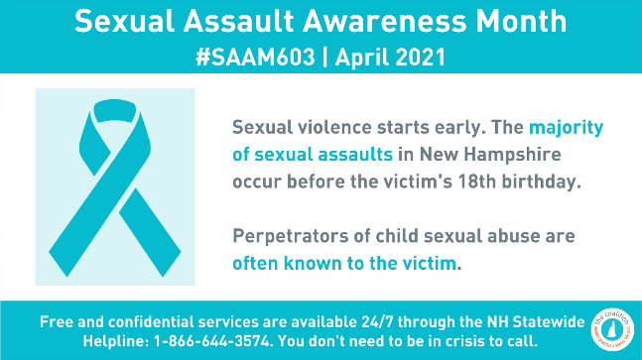
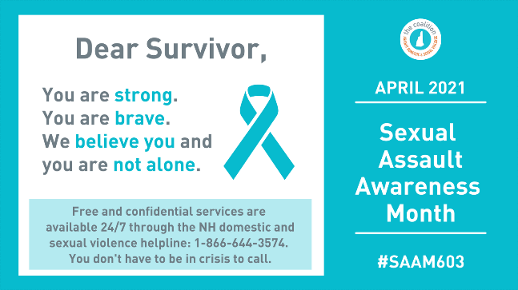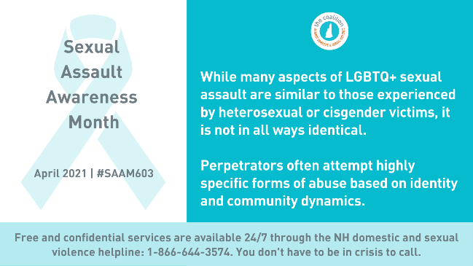
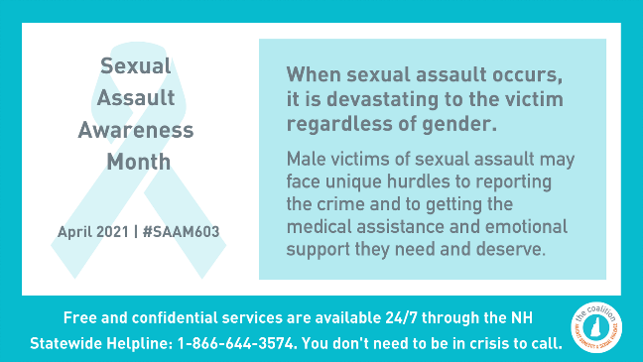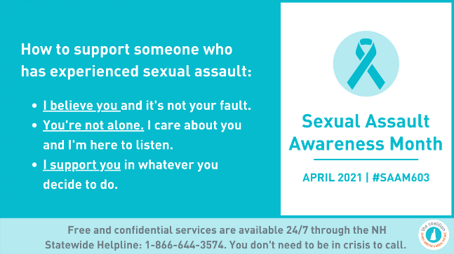

Facebook and Instagram Graphics

